**Technical Documentation – PENC MiddleWare – Patch Liferay**

1. Workflow – Stages (optionally) and Applies Liferay Patches.

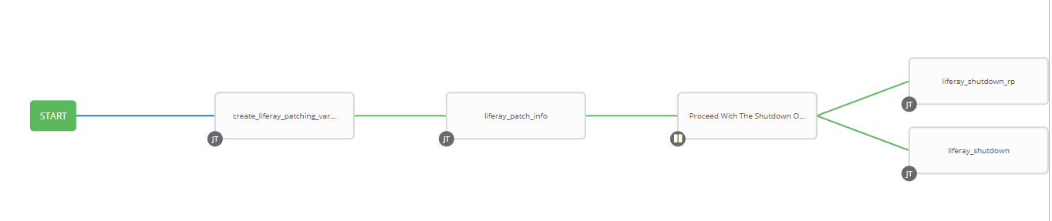

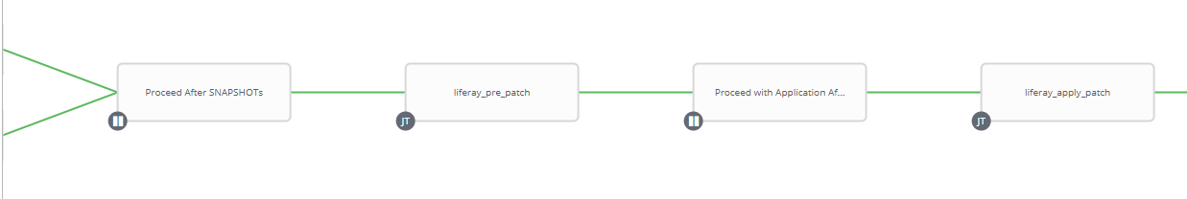

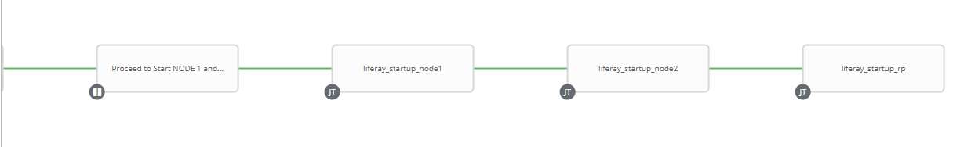

1. Survey – User Supplied Variables

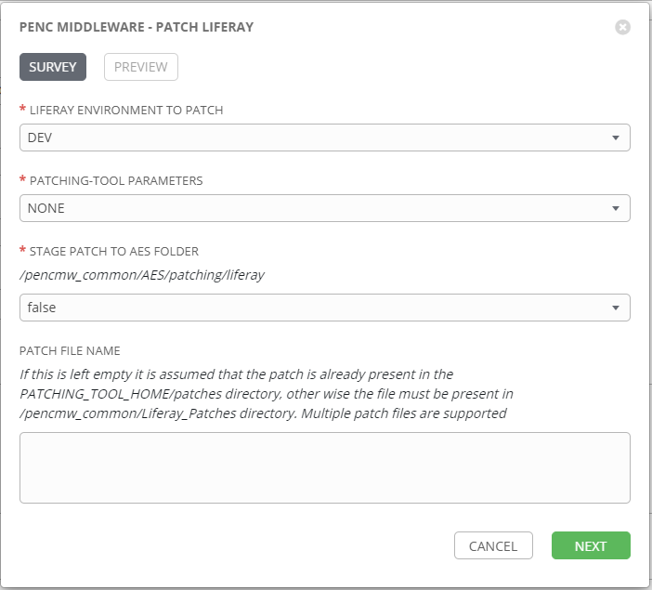

| **Survey Extra Variables** | **Prompt** | **Type** | **Description and Usage** |
| --- | --- | --- | --- |
| liferay_env | Liferay Environment To Patch | Multiple Choice Single Pick | Drop down list of the liferay environment to Patch.  Current List:  DEV  TEST  MAINT  PROD |
| patch_params | Patching-Tool Parameters | Multiple Choice Single Pick | The patching-tool parameter to use during application  Current List   * NONE – implies no parameters * REVERT – Reverts the current patches that have been previously applied (i.e. no patch is applied just the removal of the previous patches from the environment) * FORCE – Forces the application of the patch over top of any other patches (not generally recommended – Liferay Support MUST be consulted prior to using this option). |
| stage_aes_patch | Stage Patch to AES Folder | Multiple Choice Single Pick | If set to true the worklow will copy the supplied patches to the AES Patch Folder /pencmw_common/AES/patching/liferay. |
| patch_name | Patch File Name | Textarea (20,000 characters) | If this is left empty it is assumed that the patch is already present in the PATCHING_TOOL_HOME/patches directory, otherwise the file must be present in /pencmw_common/Liferay_Patches directory. Multiple patch files are supported. |

1. Jobs Used by the workflow - http://owl.penc.local:18080/svn/deploy_automation/trunk/Ansible_PlayBooks/Utilities

| **Job Template** | **Ansible Playbook** | **Credentials / host** | **Project** | **Description and Usage** |
| --- | --- | --- | --- | --- |
| create_liferay_patching_vars | create_liferay_patching_vars_ansible.yml | None – runs on localhost as awx linux user | Utilities | Creates Variables/Artifacts for use within the workflows, based on the User supplied survey results.  Artifacts Defined with examples  aes_patch_stage_dir: /pencmw_common/AES/patching/liferay  date_time: '20210304_1448'  liferay_home: /pencmw/liferay  liferay_host1: dliferay71bcp  liferay_host2: dliferay72bcp  liferay_port: 4443  liferay_protocol: https  liferay_proxy: myaccountdev1.pensionsbc.ca  patch_tool_home: /pencmw/liferay/patching-tool  patch_tool_script: patching-tool.sh  rp_host: 'mese1bcp,mese2bcp'  rp_service: httpd_dev1  tomcat_home: /pencmw/liferay/tomcat  tower_host: pdeploy1bcp.penc.local |
| liferay_patch_info | liferay_patch_info.yml | pencmw on {{liferay_host1}} and {{liferay_host2}} | Utilities | On {{liferay_host1}} and {{liferay_host2}}:   * If patch filenames are supplied in the survey, moves any old patch files from the patch_tool_home/patches to the history subfolder. * Copies each patch filename supplied in the survey from /pencmw_common/Liferay_Patches to the patch_tool_home/patches * If {{stage_aes_patch}} is true copy each patch file to the AES Staging folder * Executes {{patch_tool_home}}/patching-tool.sh info * Emails the output of the patching-tool.sh info to the Tower User. |
| Proceed With The Shutdown Of Liferay Services For SNAPSHOTs | Approval | None | Utilities | Allows the workflow initiator to review the patching-tool.sh info output and proceed with the shutdown of the reverse proxy, liferay and elastic search services so that snapshots can be taken or cancel the workflow if the REVERT or FORCE option needs to be used. |
| liferay_shutdown_rp | liferay_shutdown_rp.yml | pencmw for {{rp_host}} | Utilities | Shuts down the reverse proxy service {{rp_service}} on nodes defined in {{rp_host}}. |
| liferay_shutdown | liferay_shutdown.yml | pencmw on {{liferay_host1}} and {{liferay_host2}} | Utilities | Shuts down elastic search and the liferay tomcat services on both {{liferay_host1}} and {{liferay_host2}}. |
| Proceed_After_SNAPSHOTS | Approval | None | Utilities | Allows the workflow to continue after the snapshots have been completed. |
| liferay_pre_patch | liferay_pre_patch.yml | pencmw on {{liferay_host1}} and {{liferay_host2}} | Utilities | On {{liferay_host1}} and {{liferay_host2}}:   * Starts elastic search $ES_HOME/bin/start-esh.sh * Backs up {{tomcat_home}}/webapps/ROOT/WEB-INV/web.xml to web.xml.{{date_time}} * Executes {{patch_tool_home}}/patching-tool.sh revert if REVERT has been selected * Sends the output from the patching-tool.sh revert to the tower user if REVERT has been selected. |
| Proceed with Patch Application After Possible Revert | Approval | None | Utilities | Allow the workflow initiator to review the patching-tool.sh revert output prior to proceeding with the application of the patch. The output is only sent if the REVERT parameter has been selected. |
| liferay_apply_patch | liferay_apply_patch.yml | pencmw on {{liferay_host1}} and {{liferay_host2}} | Utilities | On {{liferay_host1}} and {{liferay_host2}}:   * Executes {{patch_tool_home}}/patching-tool.sh install if FORCE was NOT selected * Executes {{patching_tool_home}}/patching-tool.sh force if FORCE was selected * Sends the output of patching-tool.sh to the initiator of the workflow |
| Proceed to Start NODE 1 and NODE 2 | Approval | None | Utilities | Allow the workflow initiator to review the output of the patch application prior to starting the liferay services |
| liferay_startup_node1 | liferay_startup_node1.yml | pencmw on {{liferay_host1}} | Utilities | On {{liferay_host1}}   * Updates /penmw/liferay/portal-ext.properties setting database.indexes.update.on.startup=true * Starts liferay tomcat service * Updates /penmw/liferay/portal-ext.properties setting database.indexes.update.on.startup=false |
|  |  |  |  |  |

1. Workflow Extra Vars – Defined at the Workflow Level

|  |  |  |
| --- | --- | --- |
| **Extra Variable** | **Example Values** | **Description and Usage** |
| aes_mail_list | ---  aes_mail_list:  - Mike.Charchuk@dxcas.com | If this variable is defined to anything other than ‘’ and {{notifiy_aes}} == true, and email will be sent addresses defined in aes_mail_list on the actions executed.  Note: the following are valid aes_mail_list entries:  aes_mail_list: ‘’  aes_mail_list:   * [Mike.Charchuk@pensionsbc.ca](mailto:Mike.Charchuk@pensionsbc.ca) * [Mike.Charchuk@dxcas.com](mailto:Mike.Charchuk@dxcas.com)   aes_mail_list:   * [Mike.Charchuk@pensionsbc.ca](mailto:Mike.Charchuk@pensionsbc.ca) |